**2-D Array**

* In java multidimensional arrays are not implemented in matrix form, they implemented by using array of array concept.

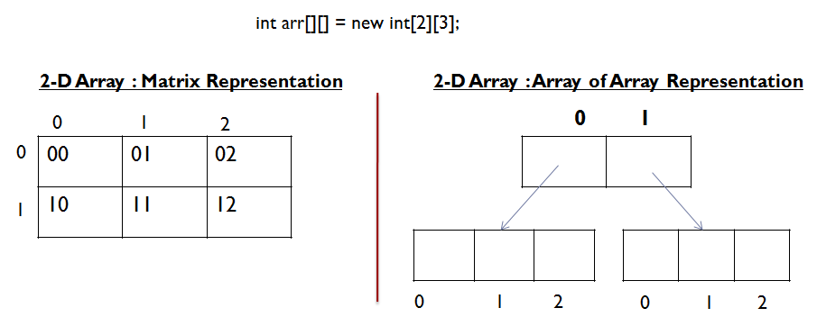

* This approach will improve memory utilization.

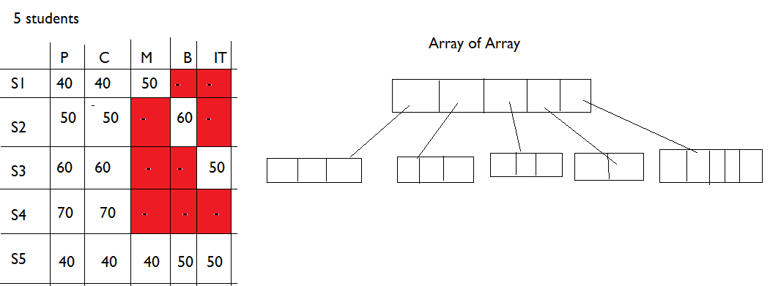

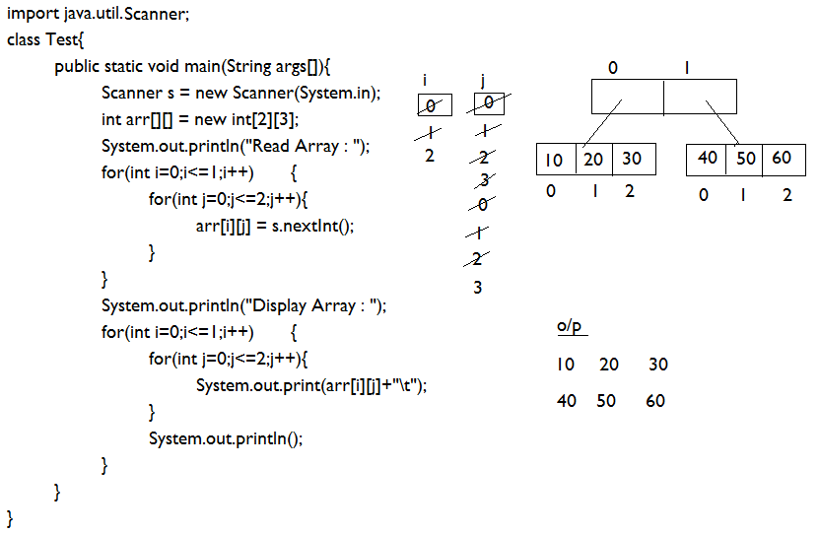

**2-D Array Initialization**

* Initializing a two dimensional array requires enclosing each row's initialization list in its own set of braces.

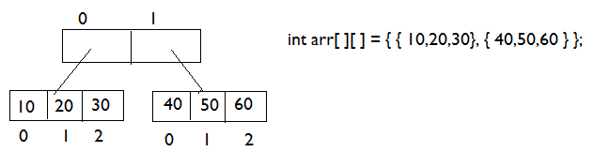

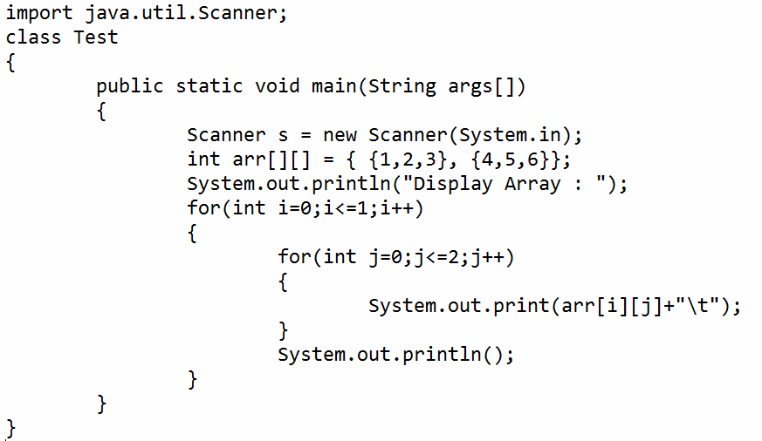

**Jagged Array**

* 2-D arrays with variable number of columns in each row are known as Jagged arrays.

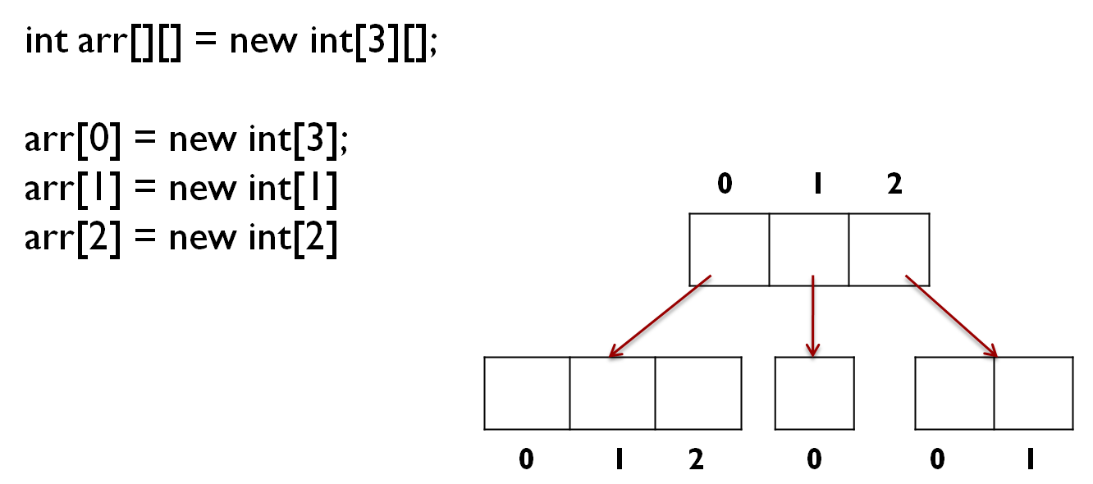

import java.util.Scanner;

class Test

{

public static void main(String args[])

{

Scanner s = new Scanner(System.in);

int arr[][] = new int[2][];

arr[0] = new int[3];

arr[1] = new int[2];

System.out.println("Read Array : ");

for(int i=0;i<=1;i++)

{

for(int j=0;j<=arr[i].length-1;j++)

{

arr[i][j] = s.nextInt();

}

}

System.out.println("Display Array : ");

for(int i=0;i<=1;i++)

{

for(int j=0;j<=arr[i].length-1;j++)

{

System.out.print(arr[i][j]+"\t");

}

System.out.println();

}

}

}

**Jagged Array Initialization**

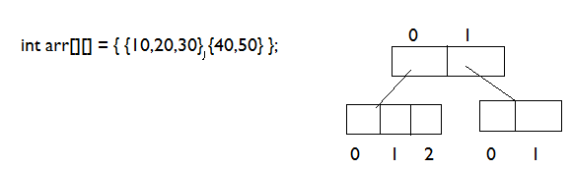

class Test

{

public static void main(String args[])

{

int arr[][] = { {10,20,30}, {40,50}};

System.out.println("Display Array : ");

for(int i=0;i<=1;i++)

{

for(int j=0;j<=arr[i].length-1;j++)

{

System.out.print(arr[i][j]+"\t");

}

System.out.println();

}

}

}

**Assignment#1**

1. Write a program to find largest element in the array?

int arr[] = {10,100,20,300,40};

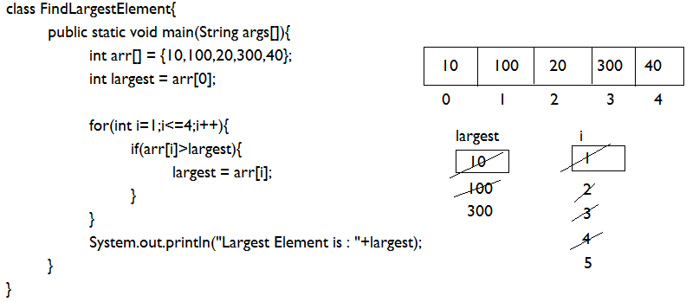

2. Write a program to find smallest element in the array?

int arr[] = {10,100,20,300,40};

class FindSmallestElement{

public static void main(String args[]){

int arr[] = {10,100,20,300,40};

int smallest = arr[0];

for(int i=1;i<=4;i++){

if(arr[i]<smallest){

smallest = arr[i];

}

}

System.out.println("Smallest Element is : "+smallest);

}

}

3. Write a program to find sum of largest and smallest element of the array?

class FindSumSmallestLargest{

public static void main(String args[]){

int arr[] = {10,100,20,300,40};

int largest = arr[0];

int smallest = arr[0];

for(int i=1;i<=4;i++){

if(arr[i]>largest){

largest = arr[i];

}

if(arr[i]<smallest){

smallest = arr[i];

}

}

System.out.println("Sum : "+(largest+smallest));

}

}